Recife Report 2018
January and February
Great News to Begin the Year

New congregations – Sanharó was scheduled to begin last year but our team had trouble recruiting people to come to the “Let the Bible Speak” gospel meeting we scheduled. The church nearest them, Belo Jardim, decided to switch at the last minute and work in Gravatá. The recruiting there was more successful, and we were able to start a congregation. The Christians in Belo Jardim did not give up. In fact, last year they made contacts in Sanharó and there were conversions. This year there have been more, and the church started meeting in January.
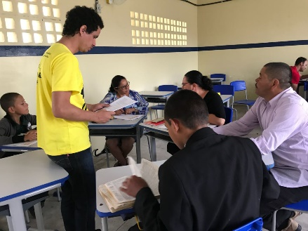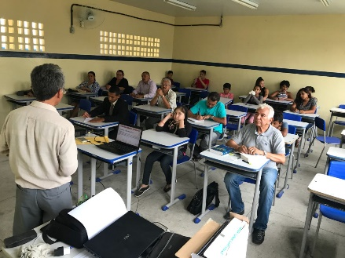
Alcides, one of our graduates in Belo Jardim has been instrumental in teaching Let the Bible Speak at Sanharó.
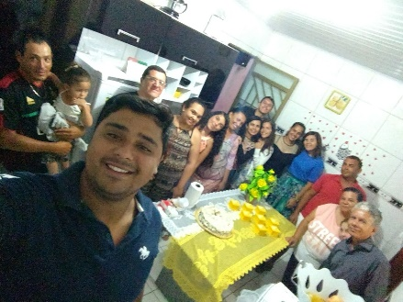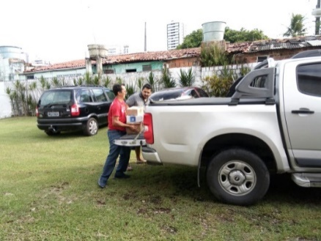
The new church in Sanharó meeting on Sunday. Materials needed to conduct the campaign were provided by us.
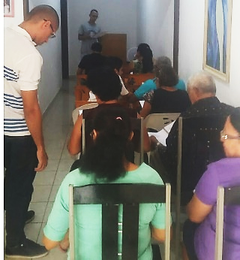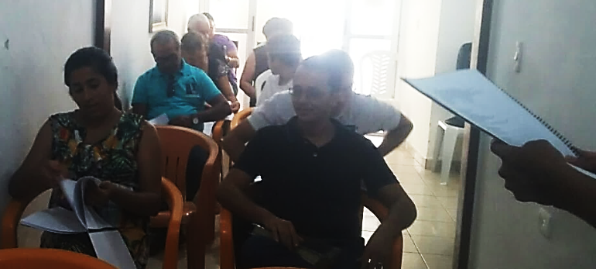
Church in Ipojuca/Cabo, worship Feb 25 2018
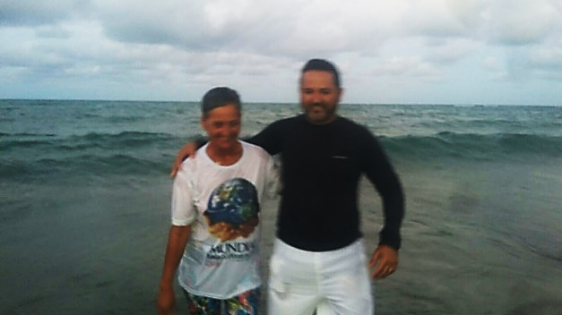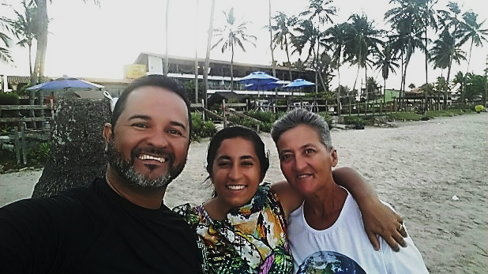
New convert just yesterday baptized his mother-in-law into Christ. He had already baptized his wife.

We had good success recruiting for our gospel meeting in Cabo and the church started there in January 2017. However, a key family moved from Cabo just over the line to Ipojuca. The new church started meeting there and we decided to do a campaign. There were 3 additional conversions in Ipojuca.

Other events in which Randy had teaching roles:
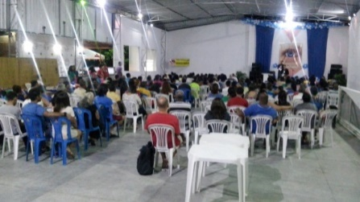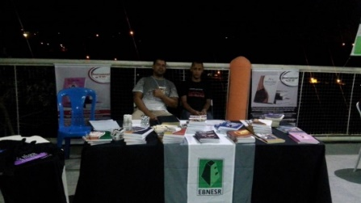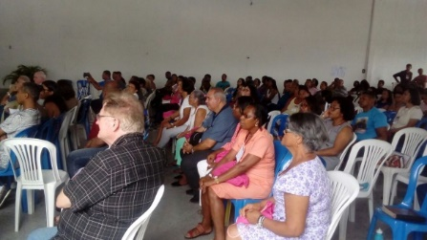
Congresso 2018, Aracaju
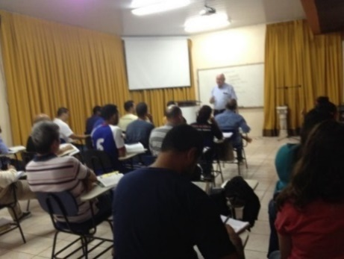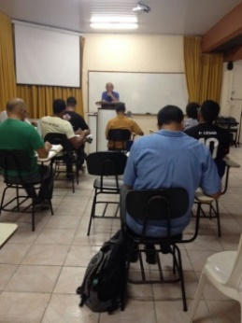
Intensive courses in January at EBNESR (Howard Norton and Enio LaTorre)
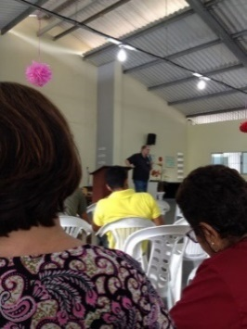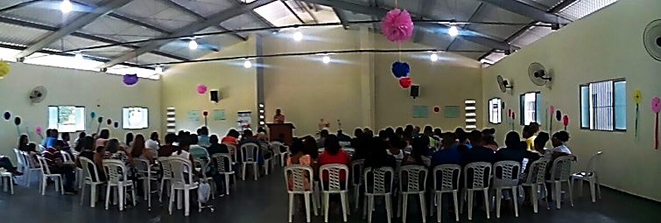
Carnaval Retreat, 2018 took place at the LAR Maná children’s home so we had some time with the children.
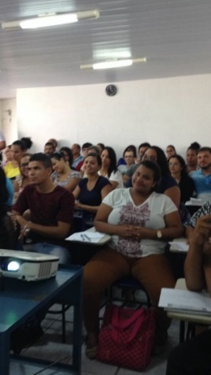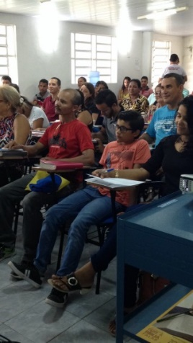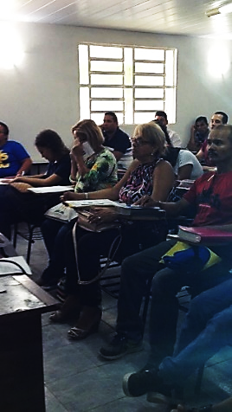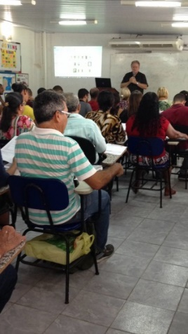
DBF class at School of Bible in Boa Viagem (Public Outreach)
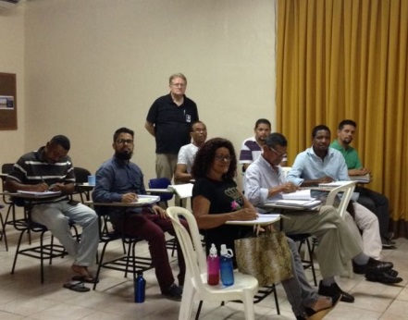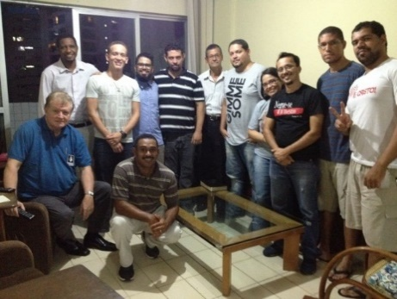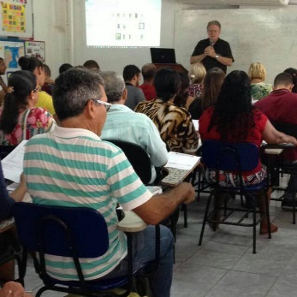
L to R: EBNESR – class on Revelation. Thursday soup and hot sauce in our house continues to be a success. Monthly Intensive Courses (More than 70 people)
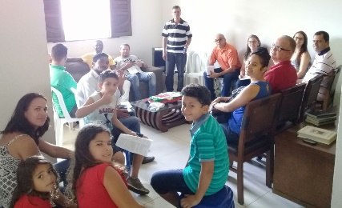
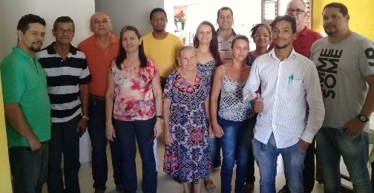
New Congregation in Arapiraca – the new Christians from Bahia who are studying at EBNESR stopped by this new congregation and worshiped with them on their way home last month.

These pictures tell the story. This year has already been very successful and busy. We pray God keeps the blessings flowing. There are 10s of millions of lost souls without Jesus and 100s of cities without churches. Continue to pray for all of our outreach efforts as we continue to share the pure and simple gospel of Jesus Christ here in the Northeast. Thank you for your financial support.

Some of you may be wondering about the 20 thousand dollars in matching funds. We have raised about ½ of that so we could still use your help. If you have not helped us reach this funding target, please do so. Every dollar you give will be matched by this anonymous giver.

God bless all,

Randy and Kathy Short, with the Bellevue Church of Christ, 7401 Highway 70 S, Nashville, TN 37221

